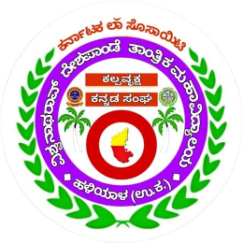
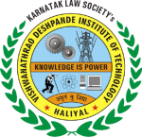
ಕೆ ಎಲ್ ಎಸ್ ವಿಶ್ವನಾಥರಾವ್ ದೇಶಪಾಂಡೆ ತಾಂತ್ರಿಕ ಮಹಾವಿದ್ಯಾಲಯ, ಹಳಿಯಾಳ
ಕಲ್ಪವೃಕ್ಷ ಕನ್ನಡ ಸಂಘ
Kannada Rajyotsava Celebration 2024
Various events were organized on November 11th 2024 at KLS VDIT, Haliyal, to celebrate the 69th Kannada Rajyotsava. The festivities included traditional games like Gombeyata (puppet Show), the distribution of prizes to competition winners, and the free distribution of Kannada technical books to government schools. Renowned Gombeyata artist Shri Siddappa Biradar,Science teacher, Govt. High School chibbalageri graced the event as a Chief Guest. The event began with the offering of flowers to the portrait of the motherland, Bhuvaneshwari, followed by the inauguration of the program.
Shri Siddappa Biradar with his Hongirana Bombeyata Kalatanda from Haliyal presented a Gombeyata (puppet show) depicting the rich culture, language, and the legacy of Karnataka's rulers. The performance featured the stories of historical figures like Rani Channamma, Onake Obavva, and Kanaka Dasa, captivating the audience with the cultural depiction through the traditional art form.
Presiding over the event, Principal Dr. V. A. Kulkarni emphasized that every Kannadiga should have at least a basic understanding of the complete history of the kings who ruled Karnataka and the works of its great writers. He also highlighted the importance of knowing the culture and traditions that Karnataka embodies. As part of the program, Siddu Biradar was honored by the college for his contributions to the art of Gombeyata.
On the occasion of Kannada Rajyotsava, the Kalpavruksha Kannada Sangha organized various competitions for students and staff, including singing, painting, Speaking in kannada and Rasaprashne (quiz). The winners of these competitions were awarded prizes during the event.
Additionally, 76 Kannada technical books were distributed free of charge to students from four government primary and high schools.
Prof. Rohini Kallur, the Secretary of Kalpavruksha Kannada Sangha, welcomed the attendees, while Kumari Sanjana Patil delivered the vote of thanks. Kumari Sanjana S. served as the anchor for the event. Over 200 students, along with all teaching and non-teaching staff, participated in the event organized by the Kalpavruksha Kannada Sangha.

